SYDNEY WESTERN CITY PLANNING PANEL

Panel Number: | PPSSWC-26
Application Number: | 2019/750/1
Local Government Area: | Camden
Development: | Alterations and additions to Macarthur Anglican School including site preparation works, construction of new one and two storey Integrated Studies Centre, refurbishment of existing buildings, modification to existing basketball courts, construction of temporary construction access, tree removal and landscaping, services, civil and associated works
Capital Investment Value: | $18,402,219
Site Address(es): | 605-635 Cobbitty Road, Cobbitty
Applicant: | Mr David Nockles
Owner(s): | The Macarthur Anglican School
Date of Lodgement: | 20 September 2019
Number of Submissions: | Nil
Classification: | Integrated development
Recommendation: | Approve with conditions
Regional Development Criteria (Schedule 7 of State Environmental Planning Policy (State and Regional Development) 2011): | Private infrastructure or community facility over $5 million
List of All Relevant Section 4.15(1)(a) Matters: | - State Environmental Planning Policy (State and Regional Development) 2011.  - State Environmental Planning Policy (Educational Establishments and Child Care Facilities) 2017.  - State Environmental Planning Policy (Sydney Region Growth Centres) 2006.  - State Environmental Planning Policy No 55 - Remediation of Land.  - Sydney Regional Environmental Plan No 20 - Hawkesbury-Nepean River.
List all Documents Submitted with this Report for the Panel’s Consideration: | - Assessment report.  - State Environmental Planning Policy (Sydney Region Growth Centres) 2006 assessment table.  - Recommended conditions.  - Proposed plans.  - Site photos.  - General Terms of Approval issued by NSW RFS.
Report Prepared By: | Jordan Soldo, Senior Town Planner.
Report Date: | April 2020.

Summary of Section 4.15 Matters

Yes
Have all recommendations in relation to relevant Section 4.15 matters been summarised in the Executive Summary of the assessment report?

Legislative Clauses Requiring Consent Authority Satisfaction

Yes
Have relevant clauses in all applicable environmental planning instruments where the consent authority must be satisfied about a particular matter been listed and relevant recommendations summarised in the Executive Summary of the assessment report?

Development Standard Contraventions

 | Yes | N/A
If a written request for a contravention to a development standard has been received, has it been attached to the assessment report?

Special Infrastructure Contributions

 | Yes | No
Does the application require Special Infrastructure Contributions?

Conditions

Yes
Have draft conditions been provided to the applicant for comment?

PURPOSE OF REPORT

The purpose of this report is to seek the Sydney Western City Planning Panel’s (the Panel’s) determination of a development application (DA) for alterations and additions to Macarthur Anglican School at 605-635 Cobbitty Road, Cobbitty.

The Panel is the consent authority for this DA as the capital investment value (CIV) of the development is $18.4 million. This exceeds the CIV threshold of $5 million (private infrastructure or community facility) for Council to determine the DA pursuant to Schedule 7 of State Environmental Planning Policy (State and Regional Development) 2011.

SUMMARY OF RECOMMENDATION

That the Panel determine DA/2019/750/1 for alterations and additions to Macarthur Anglican School pursuant to Section 4.16 of the Environmental Planning and Assessment Act 1979 by granting consent subject to the conditions attached to this report.

EXECUTIVE SUMMARY

Council is in receipt of a DA for alterations and additions to Macarthur Anglican School at 605-635 Cobbitty Road, Cobbitty.

The DA has been assessed against the Environmental Planning and Assessment Act 1979, the Environmental Planning and Assessment Regulation 2000, relevant environmental planning instruments, development control plans and policies.

A summary of the assessment of all relevant environmental planning instruments is provided below with a detailed assessment provided later in the report.

State Environmental Planning Policy (State and Regional Development) 2011. | The Panel is the consent authority for this DA as the development has a CIV of $18.4 million which exceeds the CIV threshold of $5 million (private infrastructure or community facility) for Council to determine the DA.
State Environmental Planning Policy (Educational Establishments and Child Care Facilities) 2017. | The proposed development is consistent with the requirements of the SEPP. In particular, and in accordance with clause 35 (6)(a) of the SEPP, the applicant has submitted a ‘Design Verification Statement’ prepared by a suitably qualified architect which addresses the design quality principles set out in Schedule 4.
State Environmental Planning Policy (Sydney Region Growth Centres) 2006 (Growth SEPP). | The development is permitted with consent in the applicable R1 General Residential zone, is consistent with the zone’s objectives and acceptable in terms of the Growth SEPP’s other matters for consideration.
State Environmental Planning Policy No 55 - Remediation of Land. | An Environmental Site Assessment was provided with the application. The report concludes that the site is suitable for the proposed development. Council officers accept this report subject to a standard unexpected finds condition to be included in any consent granted.
Sydney Regional Environmental Plan No 20 - Hawkesbury-Nepean River (SREP 20). | The development is consistent with the aim of SREP 20 (to protect the environment of the Hawkesbury-Nepean River system) and all of its planning controls.

The DA was publicly exhibited for a period of 14 days in accordance with Camden Development Control Plan 2019. The exhibition period was from 3 October 2019 to 16 October 2019. No submissions were received.

The proposed development has been assessed against the State Environmental Planning Policy (Educational Establishments and Child Care Facilities) 2017, State Environmental Planning Policy (Sydney Region Growth Centres) 2006, Oran Park Development Control Plan 2007 and Camden Development Control Plan 2019. The development is consistent with these planning policies and controls.

The Education SEPP requires that any provision of a development control plan (such as the Camden DCP 2019 and Oran Park DCP 2007) has no effect, regardless of when the development control plan was made. Therefore, the controls of the Camden DCP 2011 and Oran Park DCP 2007 do not apply to the site. However, it is noted that the proposal is not inconsistent with the controls contained within both DCPs.

In accordance with Clause 35(6)(a) of the State Environmental Planning Policy (Educational Establishments and Child Care Facilities) 2017, the applicant has submitted a ‘Architectural Design Statement’ prepared by a suitably qualified architect which addresses the design quality principles set out in Schedule 4.

The proposed development does not seek to accommodate additional student or staff numbers at the school. Rather, the proposed ‘Integrated Studies Centre’ building is to accommodate specialist science labs, D&T and heavy machinery workshops, an agricultural lab and a textiles room. The refurbishment of the existing TAS and cafeteria buildings will accommodate a range of spaces including an art studio, mathematics classrooms, a relocated cafeteria and kitchen and a staff centre.

Given there is no proposed increase in student or staff numbers and given the proposed works are at least 200 metres from current and likely future residential receivers, the proposed development will not result in any amenity impacts for surrounding residents. A recommended condition of consent limits student and staff numbers at the existing levels, being 1124 students and 115 staff.

The applicant has submitted an adequate stormwater management strategy that, subject to the attached conditions, will provide appropriate levels of onsite detention and water sensitive urban design outcomes.

Based on the assessment, it is recommended that the DA be approved subject to the conditions attached to this report.

AERIAL PHOTO

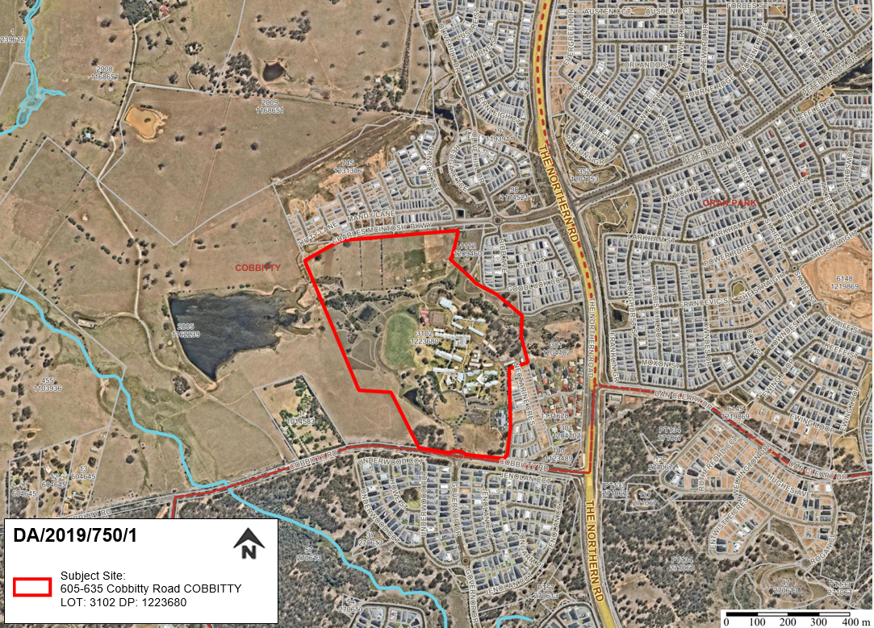
Figure 1: Aerial Photo

THE SITE

The site has an area of approximately 34.6ha and is legally described as Lot 3102 in DP 1223680. The site has road frontages to Cobbitty Road to the south and Charles McIntosh Parkway to the north. Access to the site is through the school’s main entry on Cobbitty Road. There is no vehicular access from Charles McIntosh Parkway.

The school campus is generally centrally located within the lot with an identified riparian corridor running east-west across the site to the north of the existing school buildings. To the north east is an area of moderate significant vegetation which is mapped as bush fire prone land. In terms of topography, the site slopes down from the south-east corner to the north-west, towards the dam.

The school campus currently consists of a number of permanent and demountable buildings that are generally single storey in height. The site has at grade off street parking with internal access roads. To the north of the riparian corridor are several agricultural plots. The area identified for development currently consists of basketball courts, cricket nets and two buildings which contain classrooms, toilets and a cafeteria.

Surrounding development consists of residential development nearing completion to the south, east and north. To the west is undeveloped rural land identified for future residential development.

The site is zoned part R1 General Residential and E2 Environmental Conservation pursuant to State Environmental Planning Policy (Sydney Region Growth Centres) 2006. The site is identified for a K-12 educational establishment in the Oran Park Indicative Layout Plan shown in Figure 2.

ZONING PLAN

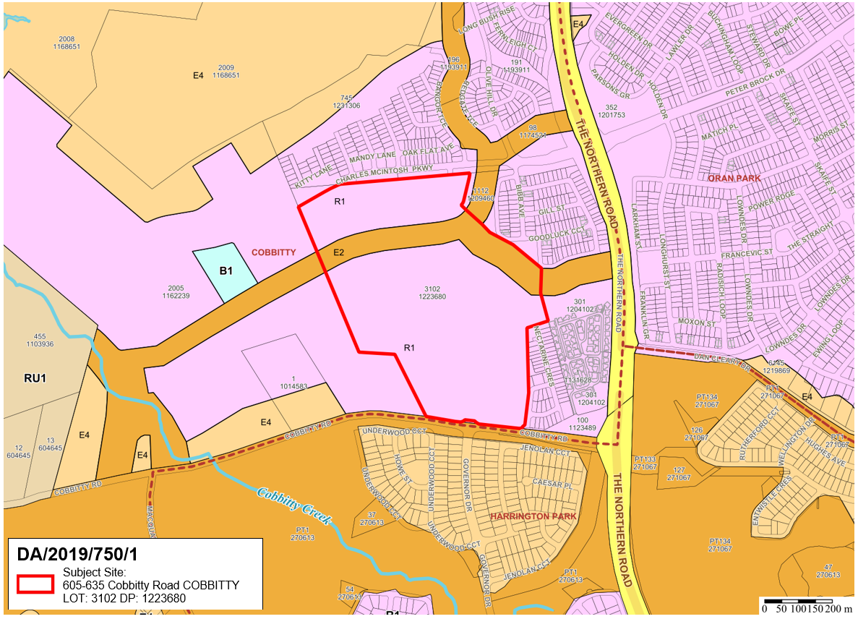
Figure 2: Zoning plan with subject lot outlined in red. The development site is entirely within the pink coloured R1 zone.

AREA MASTER PLAN

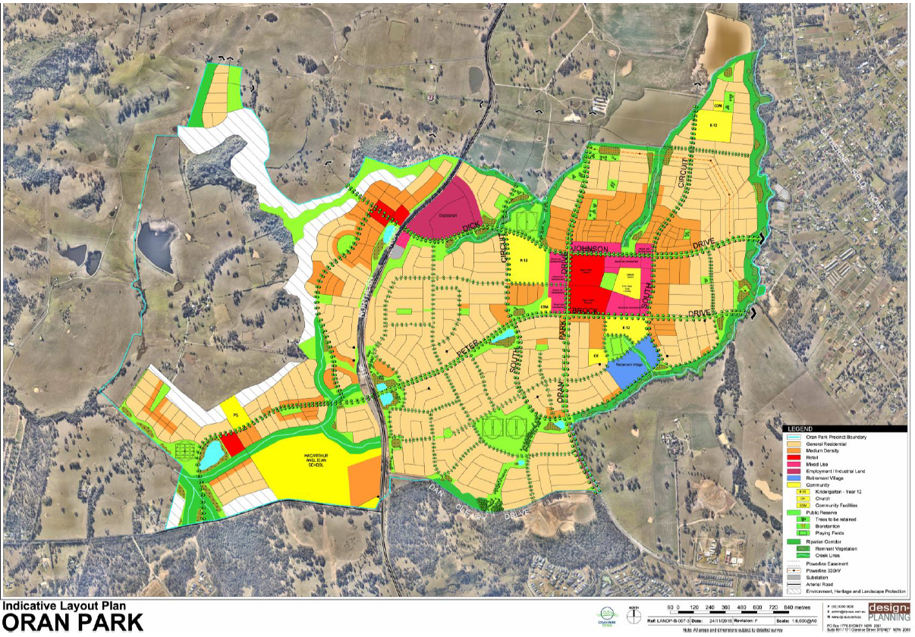
Subject Site
Figure 3: Indicative Layout Plan from Oran Park Development Control Plan 2007. Subject site labelled in south-western corner of the Plan.
HISTORY

The relevant development history of the site is summarised in the following table:

Date | Development
1 June 1995 | Approval of DA/1995/42/1 for the construction of a new educational establishment. Development consent limited the student and staff numbers to 712 pupils, 58 teaching staff and 13 administration staff.
27 January 2004 | Approval of DA/2003/948/1 for extensions to Macarthur Anglican School, tree removal, stage 1 junior school buildings, music complex and science block. The extension facilitated an increase in student and staff numbers to 1,124 students and 115 teachers / administration staff.
22 June 2016 | Approval of DA/2015/1478/1 for the construction of a single storey child care centre within the grounds of Macarthur Anglican School with a capacity of up to 94 children 0-5 years and 40 school aged children, removal of one tree, landscaping, car parking, signage and associated site works.

THE PROPOSAL

DA/2019/750/1 seeks approval for alterations and additions to Macarthur Anglican School.

Specifically, the development involves:

- Site preparation works including demolition of existing buildings, structures and removal of 11 trees;

- Construction of a new one and two storey Integrated Studies Centre across two separate buildings, incorporating science labs, D&T and heavy machinery workshops, an agricultural lab and a textiles room;

- Refurbishment of the existing TAS and cafeteria buildings to accommodate an art studio, maths classrooms, a relocated cafeteria and kitchen and a staff centre;

- Modifications to the existing basketball courts;

- Construction of a temporary construction access road, accessed off the school’s internal ring road;

- Services connections; and

- Site landscaping.

No change in student or staff numbers is proposed.

The CIV of the development is $18.4 million.

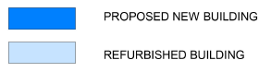
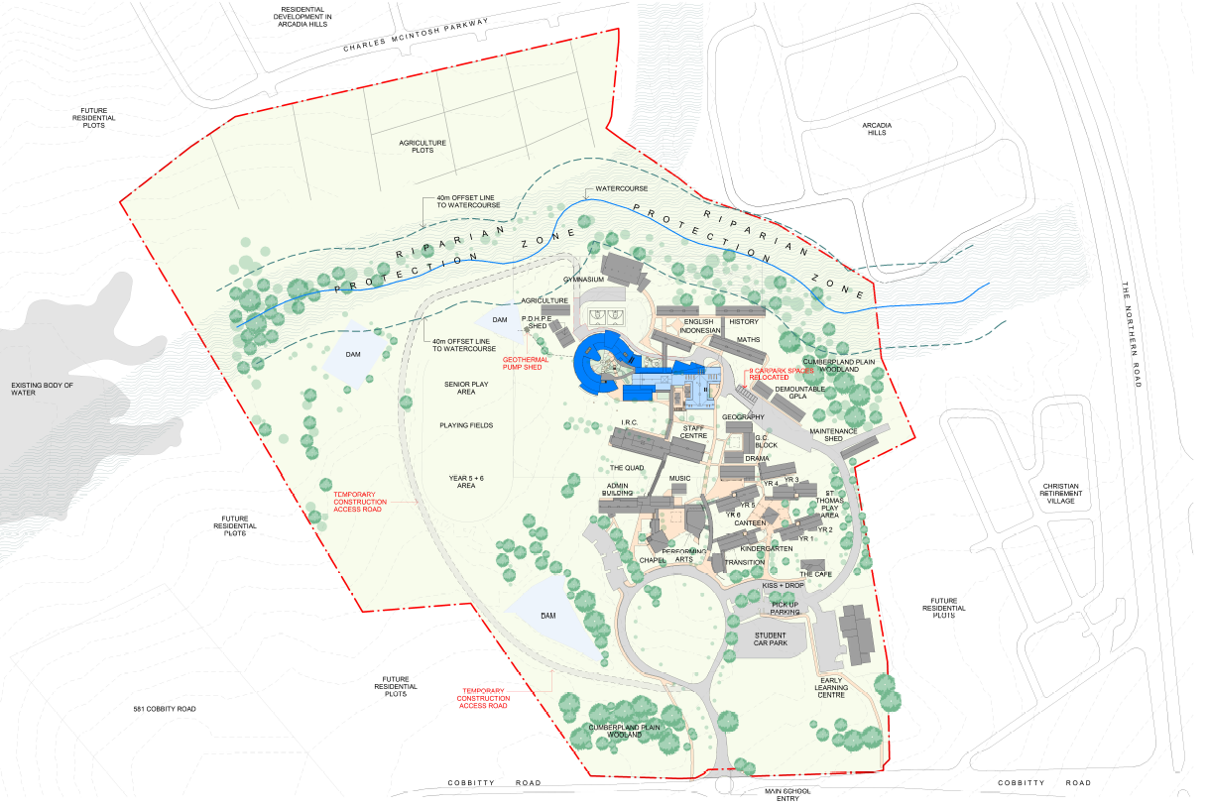
Figure 4: Proposed site plan. The proposed new buildings are shown in dark blue and buildings to be refurbished in light blue.

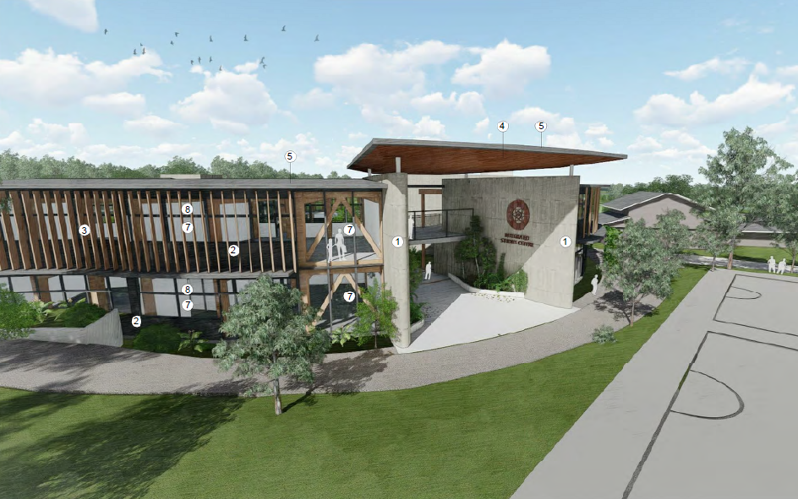
Figure 5: Perspective of the proposed building from the north.

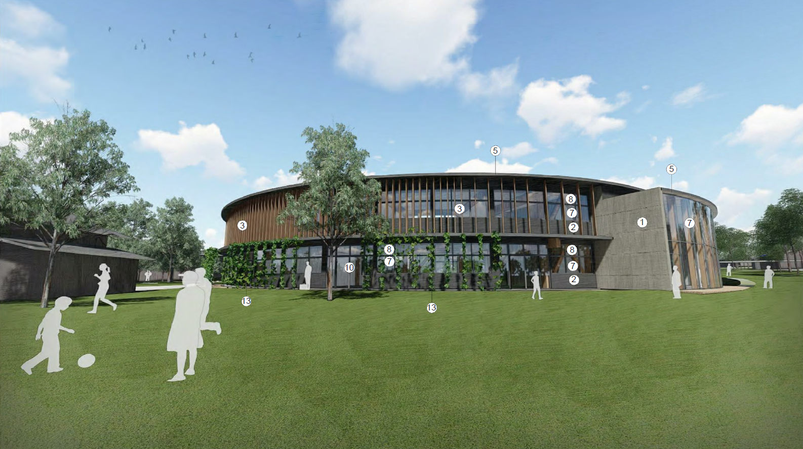
Figure 6: Perspective of the proposed building from the sporting fields to the west.

PANEL BRIEFING

Council staff briefed the Panel on the DA on 2 December 2019. The following discussion provides an assessment of how the issues raised by the Panel at the briefing have been addressed:

- Compliance with the Education SEPP to be addressed.

The proposal will comply with the Education SEPP subject to the recommended conditions attached to this report. A detailed assessment of the development’s compliance is provided below.

ASSESSMENT

Environmental Planning and Assessment Act 1979 - Section 4.15(1)

In determining a DA, the consent authority is to take into consideration such of the following matters as are of relevance to the development the subject of the DA:

(a)(i) the provisions of any environmental planning instrument

The environmental planning instruments that apply to the development are:

- State Environmental Planning Policy (State and Regional Development) 2011.
- State Environmental Planning Policy (Educational Establishments and Child Care Facilities) 2017.
- State Environmental Planning Policy (Sydney Region Growth Centres) 2006.
- State Environmental Planning Policy No 55 - Remediation of Land.
- Sydney Regional Environmental Plan No 20 - Hawkesbury-Nepean River.

State Environmental Planning Policy (State and Regional Development) 2011 (SRD SEPP)

The SRD SEPP identifies development that is State significant or regionally significant development.

The Panel is the consent authority for this DA as the CIV of the development is $18.4 million. This exceeds the CIV threshold of $5 million (private infrastructure or community facility) for Council to determine the DA pursuant to Schedule 7 of the SRD SEPP.

State Environmental Planning Policy (Educational Establishments and Child Care Facilities) 2017 (Education SEPP).

The Education SEPP applies to the subject development being for the purpose of a ‘school’. Part 4 of the Education SEPP outlines the development controls for schools where development is permitted with consent. In accordance with clause 35 (6)(a) of the SEPP, the design quality of the development has been assessed and found to be adequate when evaluated in accordance with the design quality principles. Additionally, the applicant has submitted a ‘Architectural Design Statement’ (prepared by Mayoh Architects) which addresses the design quality principles set out in Schedule 4 of the SEPP 2017.

State Environmental Planning Policy (Educational Establishments and Child Care Facilities) 2017 (Education SEPP) – Schedule 4
Clause | Assessment
Principle 1—context, built form and landscape
Schools should be designed to respond to and enhance the positive qualities of their setting, landscape and heritage, including Aboriginal cultural heritage. The design and spatial organisation of buildings and the spaces between them should be informed by site conditions such as topography, orientation and climate.  Landscape should be integrated into the design of school developments to enhance on-site amenity, contribute to the streetscape and mitigate negative impacts on neighbouring sites.  School buildings and their grounds on land that is identified in or under a local environmental plan as a scenic protection area should be designed to recognise and protect the special visual qualities and natural environment of the area, and located and designed to minimise the development’s visual impact on those qualities and that natural environment. | The proposal is centrally located within the 34.6 hectare site and complies with the maximum height of buildings development standard. The overall bulk and scale of the development is considered appropriate considering the existing building context and site topography.  A comprehensive landscape plan was provided with the application that includes a species selection and design that will enhance on-site amenity.  It is noted that the school buildings or grounds are not listed as a scenic protection area. The Camden Development Control Plan 2019 lists Cobbitty Road as a significant cultural landscape however the setback of the proposal from the road, as well as the existing screening in the form of landscaping and buildings means that the proposal is unlikely to impact upon the significance.
Principle 2—sustainable, efficient and durable
Good design combines positive environmental, social and economic outcomes. Schools and school buildings should be designed to minimise the consumption of energy, water and natural resources and reduce waste and encourage recycling.  Schools should be designed to be durable, resilient and adaptable, enabling them to evolve over time to meet future requirements. | The proposal provides a variety of devices to minimise energy consumption and reduce water and natural resources use. These include sun shading devices and rainwater harvesting.  The buildings use a structural portal frame system meaning that internal structural walls are minimised. This ensures the building is future proofed with flexibility and adaptability possible.
Principle 3—accessible and inclusive
School buildings and their grounds should provide good wayfinding and be welcoming, accessible and inclusive to people with differing needs and capabilities.  Schools should actively seek opportunities for their facilities to be shared with the community and cater for activities outside of school hours. | The proposal maintains and enhances wayfinding through the site. The design is considered accessible and is capable of complying with the NCC and access to premises standards with regard to accessibility.  There are existing opportunities for community use throughout the site including a gymnasium, a playing field, basketball courts and a general assembly area. The proposed building will not reduce the ability of the community to utilise the school for community purposes.
Principle 4—health and safety
Good school development optimises health, safety and security within its boundaries and the surrounding public domain, and balances this with the need to create a welcoming and accessible environment. | The new and refurbished buildings will contribute towards increasing the level of health, safety and security within the grounds. This will be achieved through several methods including relocating a number of car parking spaces away from school buildings and incorporating them into the main car parking area. The public domain will remain largely unaffected due to their being no increase in student or staff numbers.
Principle 5—amenity
Schools should provide pleasant and engaging spaces that are accessible for a wide range of educational, informal and community activities, while also considering the amenity of adjacent development and the local neighbourhood.  Schools located near busy roads or near rail corridors should incorporate appropriate noise mitigation measures to ensure a high level of amenity for occupants.  Schools should include appropriate, efficient, stage and age appropriate indoor and outdoor learning and play spaces, access to sunlight, natural ventilation, outlook, visual and acoustic privacy, storage and service areas. | The school currently has a wide range of educational and extracurricular spaces available for use. The new and refurbished buildings proposed as part of the subject DA will further increase the range of spaces available to students.  The proposal is located away from busy roads or rail corridors.  The proposal will enhance the existing learning and play spaces. The building design and surrounding parkland setting will provide solar access during winter months and provide shade during summer months as well as protection from the elements.
Principle 6—whole of life, flexible and adaptive
School design should consider future needs and take a whole-of-life-cycle approach underpinned by site wide strategic and spatial planning. Good design for schools should deliver high environmental performance, ease of adaptation and maximise multi-use facilities. | The proposed ‘Integrated Studies Centre’ buildings and refurbishment of the existing TAS and cafeteria buildings will improve current teaching facilities by reducing the number of demountable buildings and providing adaptable spaces which will ensure future flexibility of classroom sizes, layouts and uses.
Principle 7—aesthetics
School buildings and their landscape setting should be aesthetically pleasing by achieving a built form that has good proportions and a balanced composition of elements. Schools should respond to positive elements from the site and surrounding neighbourhood and have a positive impact on the quality and character of a neighbourhood.  The built form should respond to the existing or desired future context, particularly, positive elements from the site and surrounding neighbourhood, and have a positive impact on the quality and sense of identity of the neighbourhood. | The proposed colours, materials and overall built form are well considered, aesthetically pleasing and compatible with both the existing built form and surrounding site context.  The building aesthetics are well considered with the use of materials which are sympathetic to the natural landscape and to the wider neighbourhood beyond.

Clause 35 (6)(b) requires the consent authority to consider whether the development enables the use of the school facilities (including recreational facilities) to be shared with the community. The proposed general learning area is primarily for the use of the school to carry out teaching and ordinary functions associated with education. There are existing opportunities for community use throughout the site including a gymnasium, a playing field, basketball courts and a general assembly area. The proposed building will not reduce the ability of the community to utilise the school for community purposes.

Clause 35(9) of the SEPP requires that any provision of a development control plan (such as the Camden DCP 2019 and Oran Park DCP 2007) has no effect, regardless of when the development control plan was made. Therefore, the controls of the Camden DCP 2011 and Oran Park DCP 2007 do not apply to the development.

State Environmental Planning Policy (Sydney Region Growth Centres) 2006 (Growth SEPP)

The Growth SEPP aims to co-ordinate the release of land for residential, employment and other urban development in the North West Growth Centre, the South West Growth Centre and the Wilton Growth Area.

Site Zoning

The site is zoned R1 General Residential and E2 Environmental Conservation pursuant to Appendix 1, Clause 2.2 of the Growth SEPP.

Land Use Definitions

The development is defined as an “educational establishment” by the Growth SEPP.

Permissibility

All of the development is permitted with consent in the zones in which it is proposed pursuant to the land use table in Appendix 1 of the Growth SEPP.

Planning Controls

An assessment table in which the development is considered against the Growth SEPP’s planning controls is provided as an attachment to this report.

State Environmental Planning Policy No 55 - Remediation of Land (SEPP 55)

SEPP 55 provides a State-wide planning approach to the remediation of contaminated land.

Clause 7 of SEPP 55 requires the consent authority to consider if the site if contaminated. If the site is contaminated, the consent authority must be satisfied that it is suitable in its contaminated state for the development. If the site requires remediation, the consent authority must be satisfied that it will be remediated before the land is used for the development. Furthermore, the consent authority must consider a preliminary contamination investigation in certain circumstances.

An Environmental Site Assessment was provided with the application which found the site to be suitable for the development from a contamination perspective. Council staff have reviewed the assessment, agree with its findings and are satisfied that the site is suitable for the development.

A standard contingency condition is recommended that requires any contamination found during construction to be managed in accordance with Council's Management of Contaminated Lands policy.

Sydney Regional Environmental Plan No 20 - Hawkesbury-Nepean River (SREP 20)

SREP 20 aims to protect the environment of the Hawkesbury-Nepean River system by ensuring that the impacts of future land uses are considered in a regional context.

The development is consistent with the aim of SREP 20 and all of its planning controls. There will be no detrimental impacts upon the Hawkesbury-Nepean River system as a result of the development. Appropriate erosion, sediment and water pollution control measures have been proposed as part of the development.

(a)(ii) the provisions of any proposed instrument that is or has been the subject of public consultation under this Act and that has been notified to the consent authority (unless the Secretary has notified the consent authority that the making of the proposed instrument has been deferred indefinitely or has not been approved)

Draft Environment State Environmental Planning Policy (Draft Environment SEPP)

The development is consistent with the Draft Environment SEPP in that there will be no detrimental impacts upon the Hawkesbury-Nepean River system as a result of it.

(a)(iii) the provisions of any development control plan

Pursuant to Clause 35(9) of the State Environmental Planning Policy (Educational Establishments and Child Care Facilities) a provision of a development control plan that specifies a requirement, standard or control does not apply in relation to development for the purpose of an educational establishment that requires development consent. Therefore, an assessment of the proposal against the Camden Development Control Plan 2019 or Oran Park Development Control Plan 2007 is not required.

Issues ordinarily considered under these DCPs relating to environmental management, erosion and sedimentation, salinity, water management, waste management, acoustics, traffic and parking are considered elsewhere within this report or are addressed via recommended conditions of consent.

(a)(iiia) the provisions of any planning agreement that has been entered into under section 7.4, or any draft planning agreement that a developer has offered to enter into under section 7.4

No relevant planning agreement or draft planning agreement exists or has been proposed as part of this DA.

(a)(iv) the regulations (to the extent that they prescribe matters for the purposes of this paragraph)

The Environmental Planning and Assessment Regulation 2000 prescribes several matters that are addressed in the conditions attached to this report.

(b) the likely impacts of the development, including environmental impacts on both the natural and built environments, and social and economic impacts in the locality

As demonstrated by the assessment, the development is unlikely to have any unreasonable adverse impacts on either the natural or built environments, or the social and economic conditions in the locality.

Traffic and Parking Impacts

The proposed ‘Integrated Studies Centre’ buildings and refurbishment of the existing TAS and cafeteria buildings consists of an additional 2,540m² floor area to be utilised by the school. The applicant has indicated that the additional floor area is not intended to accommodate additional student or staff numbers at the school. For this reason, no additional parking is proposed or required for this development.

The applicant has indicated that the additional floor area is to accommodate specialist science labs, D&T and heavy machinery workshops, an agricultural lab and a textiles room.

Given that no increase in student or staff numbers is proposed and that the proposed works are at least 200 metres from current and likely future residential receivers, a detailed traffic report was not required for the assessment. Council staff have reviewed the application and supporting information and satisfied that the proposal is unlikely to adversely impact on the sounding land uses subject to a condition limiting student and staff numbers at the existing levels, being 1124 students and 115 staff.

Waterfront Land

Two watercourses traverse the site. No works are proposed within the riparian protection area as depicted in the Growth SEPP or on waterfront land as defined in the Oran Park and Turner Road Waterfront Land Strategy 2009. The Natural Resources Access Regulator has confirmed that a controlled activity approval is not required for this proposal.

Bush Fire Impacts

A portion of the site is mapped as bush fire prone land along the riparian protection area which renders the proposal defined as a special bush fire protection purpose pursuant to Section 100B(6)(a) of the Rural Fires Act 1997. Therefore, the development is classed as integrated development and the DA was referred to the NSW Rural Fire Service (RFS) for approval.

The RFS has subsequently issued General Terms of Approval and a Bush Fire Safety Authority for the development subject to conditions related to the establishment of asset protections zones, water and utilities, evacuation and emergency management and landscaping. Compliance with the GTAs and BFSA is a recommended condition and in doing so any potential bush fire impacts upon the development will be satisfactorily mitigated.

Acoustics

A detailed acoustic report was not required for the proposal given no increase in student numbers is proposed; the external play spaces and ovals remain unchanged; and the new and refurbished buildings are located at least 200 metres from current and likely future residential receivers and will generally be shielded by existing building on site.

Tree Removal

The proposal involves the removal of 10 trees and one shrub in the location in which the proposed works are located. An Arboricultural Impact Statement was provided with the application which found that most of the species are exotics and all have been planted on the site as part of the landscaping around the school buildings. It also found that none of the trees were of any significant historical and environmental importance and could be replaced in other areas of the school by additional planting of suitable small tree species. Council staff have reviewed the plans and the Statement and agree with its findings.

European Heritage - Narellan Camp

Whilst the site is not listed as containing any heritage items in the Growth Centres SEPP, figure 25 of the Oran Park Precinct Development Control Plan 2007 identifies the indicative location of a former military camp, known as Narellan Camp. A Heritage Impact Statement (HIS) has previously been submitted and assessed under DA/2015/1478/1 which approved a child care centre within the grounds of Macarthur Anglican School.

The HIS outlined the camp was dismantled after the Second World War and no visible evidence of the items exist. No further assessment is required under this application however a condition of consent has been recommended so that if any below ground relics are located, works must cease, and the Heritage Council of NSW be contacted to obtain their requirements prior to works recommencing.

(c) the suitability of the site for the development

As demonstrated by the above assessment, the site is considered to be suitable for the development.

(d) any submissions made in accordance with this Act or the regulations

The DA was publicly exhibited for a period of 14 days in accordance with Camden Development Control Plan 2019. The exhibition period was from 3 October 2019 and 16 October 2019. No submissions were received in response.

(e) the public interest

The public interest is served through the detailed assessment of this DA under the Environmental Planning and Assessment Act 1979, the Environmental Planning and Assessment Regulation 2000, environmental planning instruments, development control plans and policies. Based on the above assessment, the development is consistent with the public interest.

EXTERNAL REFERRALS

The external referrals undertaken for this DA are summarised in the following table:

External Referral | Response
NSW Rural Fire Service. | The NSW Rural Fire Service issued General Terms of Approval and a Bush Fire Safety Authority subject to conditions on 22 October 2019.
NSW Natural Resources Access Regulator. | The application was discussed with NRAR at the time of lodgement who confirmed that the application did not require a controlled activity approval and was therefore not integrated development with respect to the Water Management Act 2000.

Conditions that require compliance with the General Terms of Approval and Bush Fire Safety Authority are recommended.

FINANCIAL IMPLICATIONS

This matter has no direct financial implications for Council.

CONCLUSION

The DA has been assessed in accordance with Section 4.15(1) of the Environmental Planning and Assessment Act 1979 and all relevant instruments, plans and policies. The DA is recommended for approval subject to the conditions attached to this report.

RECOMMENDED

That the Panel approve DA/2019/750/1 for alterations and additions to Macarthur Anglican School at 605-635 Cobbitty Road, Cobbitty subject to the conditions attached to this report.

